EVO: Self-Evolving OSS Project Manager Agent

EVO is an agent that can serve as a project manager, organizing tasks and ensuring work quality for open.
The agent will proactively exercise various aspects of the software development life cycle, such as prioritizing and assigning project tasks, judging code correctness and deployment readiness, and assisting human engineers with root cause analysis for failures. This agent enables human developers to drive software projects to completion in a timely manner without worrying about smaller details that could introduce friction in the development process.
Overview of the AI software development life cycle:
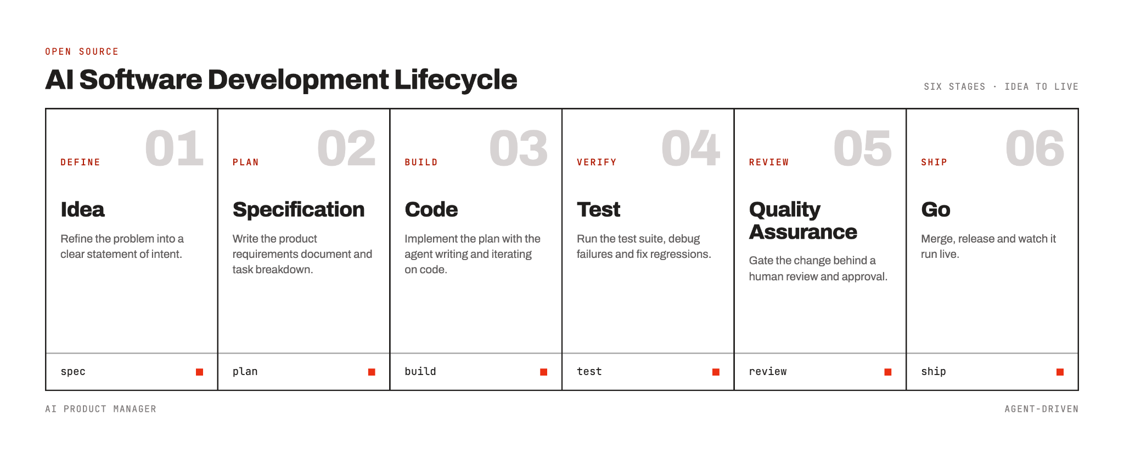
Link to GH: https://github.com/viktorinkov/agi-nutanix-oss-agent

